Parallel Programming Assignment Report

Students Information
Student Name: samer saad / Mena magdy / Abanoub hashmet / Bassem adel

Problem Information
Problem Title: Parallel Calculation of PI without Race Condition and False Sharing
Lecture Number: Lecture 2 and Section 5 – Race Condition and False Sharing

Problem Description
The objective of this problem is to calculate the value of PI using numerical integration and OpenMP parallel programming. The computation is divided among multiple threads to improve performance and reduce execution time.
The program evaluates the mathematical function:
PI = ∫(4 / (1 + x²)) dx from 0 to 1

Parallelization Approach
The work is distributed among multiple threads using OpenMP.
To avoid False Sharing, a padded two-dimensional array is used:
double partialSum[MAX_THREADS][PAD];
Each thread updates only its own element:
partialSum[threadId][0]
This ensures that different threads do not compete for the same cache line.

Solution Explanation
- The integration interval is divided into a large number of steps.
- OpenMP creates multiple threads.
- Each thread processes a subset of iterations.
- Partial results are stored in separate padded memory locations.
- After all threads finish, the partial sums are combined.
- The final value of PI is calculated and displayed.
- Execution time is measured using omp_get_wtime().
This implementation eliminates Race Conditions and minimizes False Sharing.

Source Code
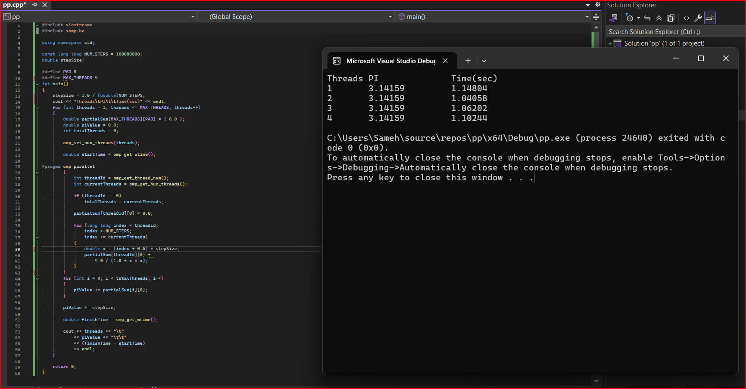

Execution Results
The program was executed using different numbers of threads.

Sample Output
Threads PI Time(sec)
1 3.14159 1.14
2 3.14159 1.04
3 3.14159 1.08
4 3.14159 0.97

Conclusion
The OpenMP implementation successfully parallelized the PI calculation. Race Conditions were avoided by using thread-specific partial sums, while False Sharing was eliminated through memory padding. The parallel version achieved better performance and reduced execution time compared to the sequential execution.

